~Day-4
- Connect a USB webcam to your computer, install any required drivers, and verify that the webcam works by opening the default camera app and capturing a photo.

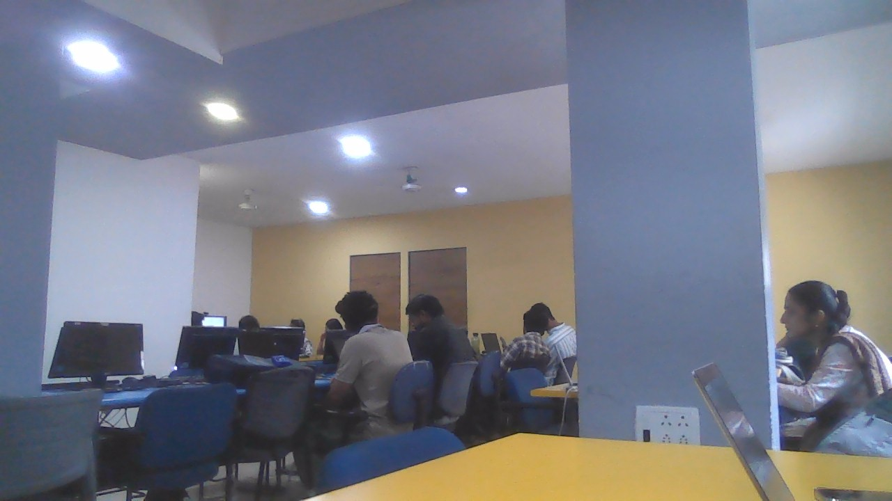
:-The USB webcam was successfully connected and detected by my Laptop. The required drivers were installed, and the webcam was tested using the Camera application. A test photo was captured successfully, confirming that the webcam is functioning properly.
- Set up a local printer (USB or network), install the correct driver, and print a test page to confirm successful installation.

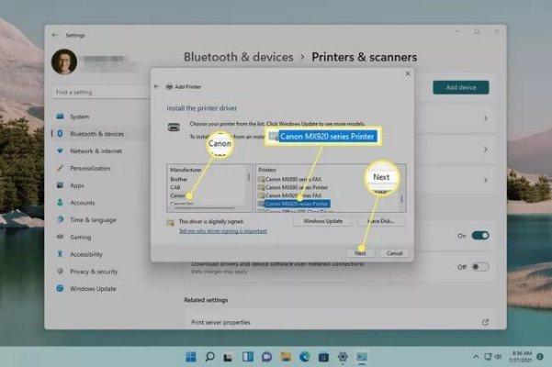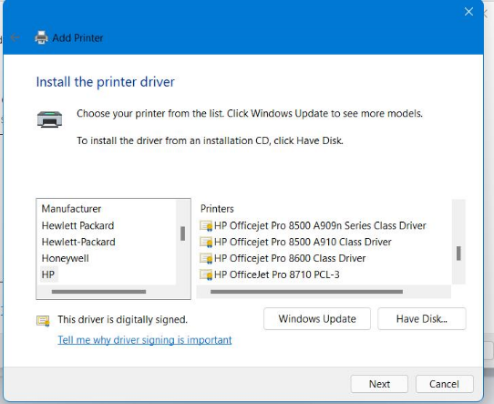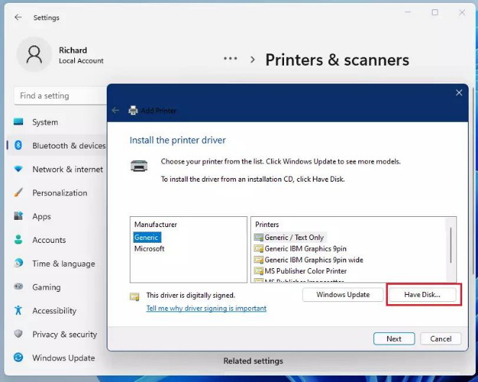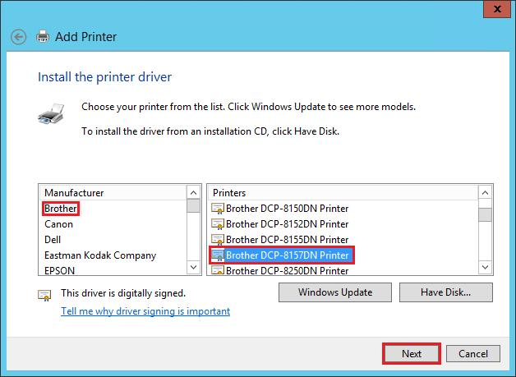

Printer Driver Installation
- Connected the printer to the computer using a USB cable (or connected it to the same Wi-Fi network).
- Opened Settings → Bluetooth & Devices → Printers & Scanners.
- Selected Add Device and chose the printer from the list.
- Windows automatically downloaded and installed the appropriate printer driver, or the driver was installed from the manufacturer's website.
- After installation, the printer appeared in the list of available printers.
- Opened Printer Properties and selected Print Test Page.
- The test page printed successfully, confirming that the printer and driver were installed correctly.
- Simulate a connectivity issue by unplugging the printer's USB cable, then use Windows Device Manager to identify and resolve the 'printer not detected' problem.<br><br><em><strong>Hint:</strong> Check for error icons and use the 'Scan for hardware changes' option after reconnecting.</em>

:-Steps Performed
- Verified that the printer was working correctly and connected to the computer.
- Unplugged the printer's USB cable from the computer.
- Attempted to print a document and observed that the printer was not detected.
- Pressed Windows + X and selected Device Manager.
- Expanded the Printers or Universal Serial Bus Controllers section.
- Checked for:
  - A yellow warning icon (!)
  - An unknown device entry
  - The printer missing from the device list
- Reconnected the printer's USB cable securely.
- In Device Manager, clicked Action → Scan for hardware changes.
- Waited for Windows to detect the printer and reinstall the device if necessary.
- Confirmed that the printer reappeared in Device Manager without any warning icons.
- Opened Settings → Bluetooth & devices → Printers & scanners and verified that the printer was listed as available.
- Printed a test page to confirm the issue was resolved.
Observations
- When the USB cable was disconnected, the printer was not detected by Windows.
- After reconnecting the cable and using Scan for hardware changes, Windows successfully recognized the printer again.
Result
The "printer not detected" issue was successfully identified and resolved using Device Manager. The printer was detected after reconnecting the USB cable and scanning for hardware changes, and a test page printed successfully.

- A user reports that their webcam video is not displaying in Zoom, but it works in the default camera app. Troubleshoot and resolve the issue so the webcam works in both applications.<br><br><em><strong>Hint:</strong> Check if another app is using the webcam or if Zoom permissions are enabled.</em>
:-Steps Taken
- Verified that the webcam worked correctly by opening the Camera app and checking the live video feed.
- Closed the Camera app and any other applications that might be using the webcam (Microsoft Teams, Skype, Discord, OBS, browser tabs, etc.).
- Opened Zoom and navigated to Settings → Video.
- Confirmed that the correct webcam was selected from the camera drop-down menu.
- Checked Windows camera permissions:
  - Opened Settings → Privacy & Security → Camera.
  - Ensured Camera Access was enabled.
  - Ensured Let desktop apps access your camera was turned on.
  - Verified that Zoom had permission to use the camera.
- Restarted Zoom and tested the camera again.
- If the issue persisted, opened Device Manager and checked the webcam for warning icons or driver issues.
- Updated or reinstalled the webcam driver if necessary.
- Restarted the computer and launched Zoom again.
- Started a test meeting and confirmed that the webcam video appeared correctly.
Cause Identified
The webcam hardware and driver were functioning properly because the Camera app could access it. The issue was caused by either:
- Another application using the webcam, or
- Camera permissions not being enabled for Zoom.
Result
After closing other applications and ensuring Zoom had camera permissions, the webcam was detected successfully in Zoom and displayed video correctly during meetings.

THE END….

